#### 

#### IFT 598 Middle Programming and Database Security

#### Shraddha Surendra Kumbharkar

# Module 3 Assignment: Data Format

#### Professor, Dinesh Sthapit

#### Sept 24 by 11:59pm

#### 

#### **Reusable components to create a composite components:-1**

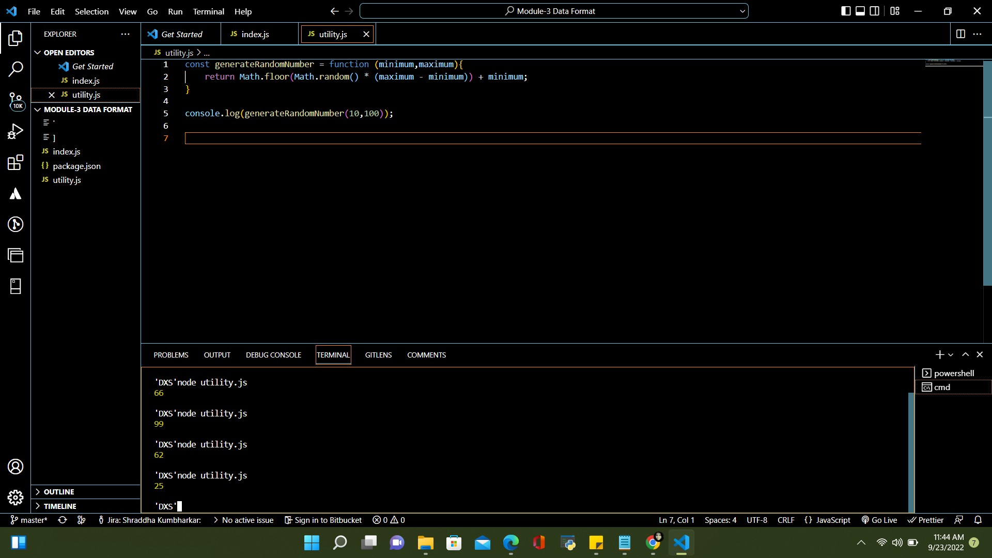

**Error 1: include module type in package.json**

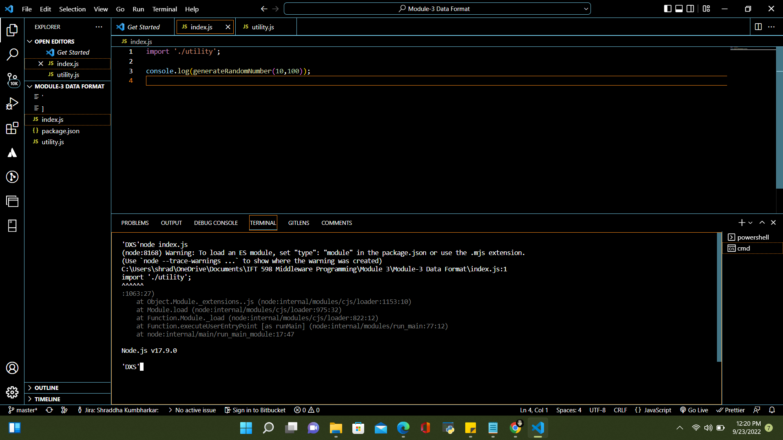

**Error 2:Give extension while importing a module in js file**

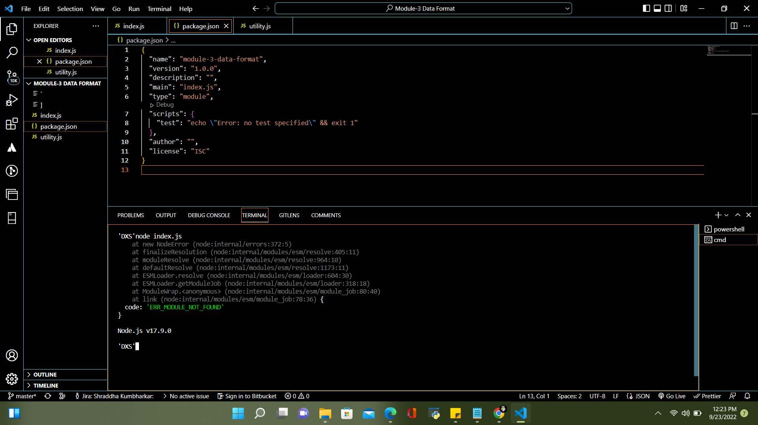

**Error3: Export the function and then import it in index.js file**

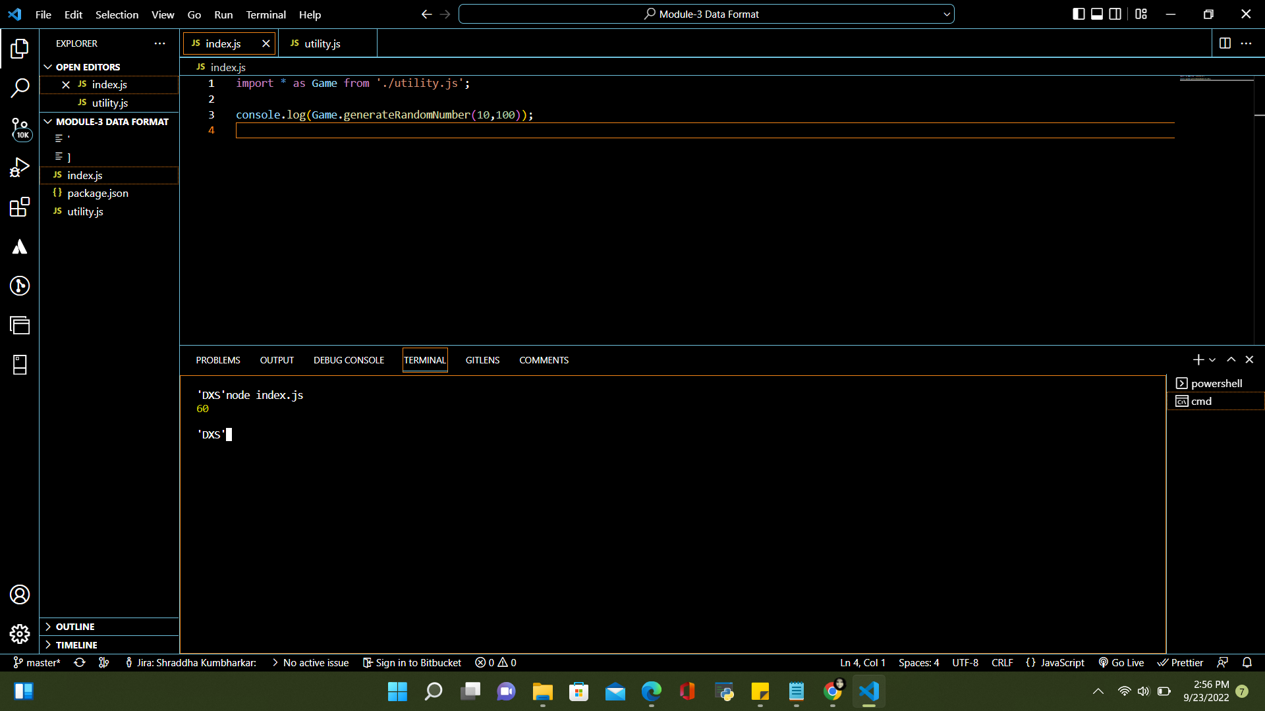

**Code with correct output**

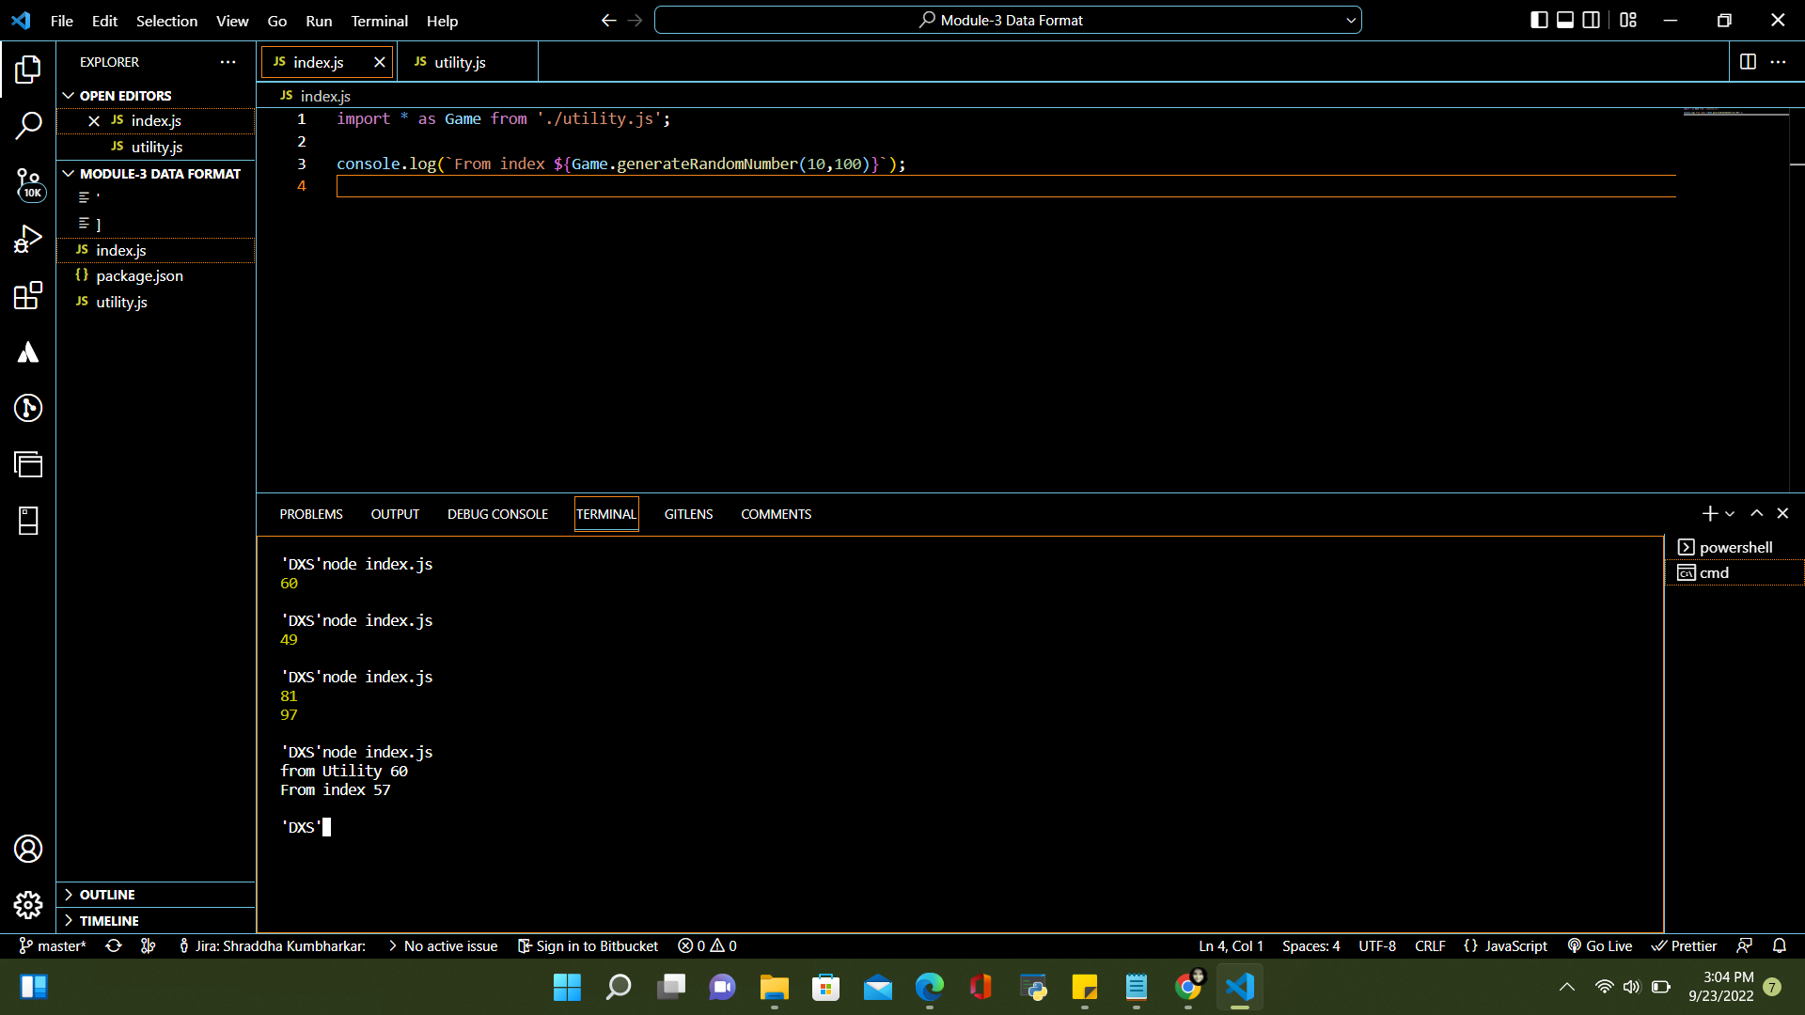

**Using Importing External Modules (third-party modules)**

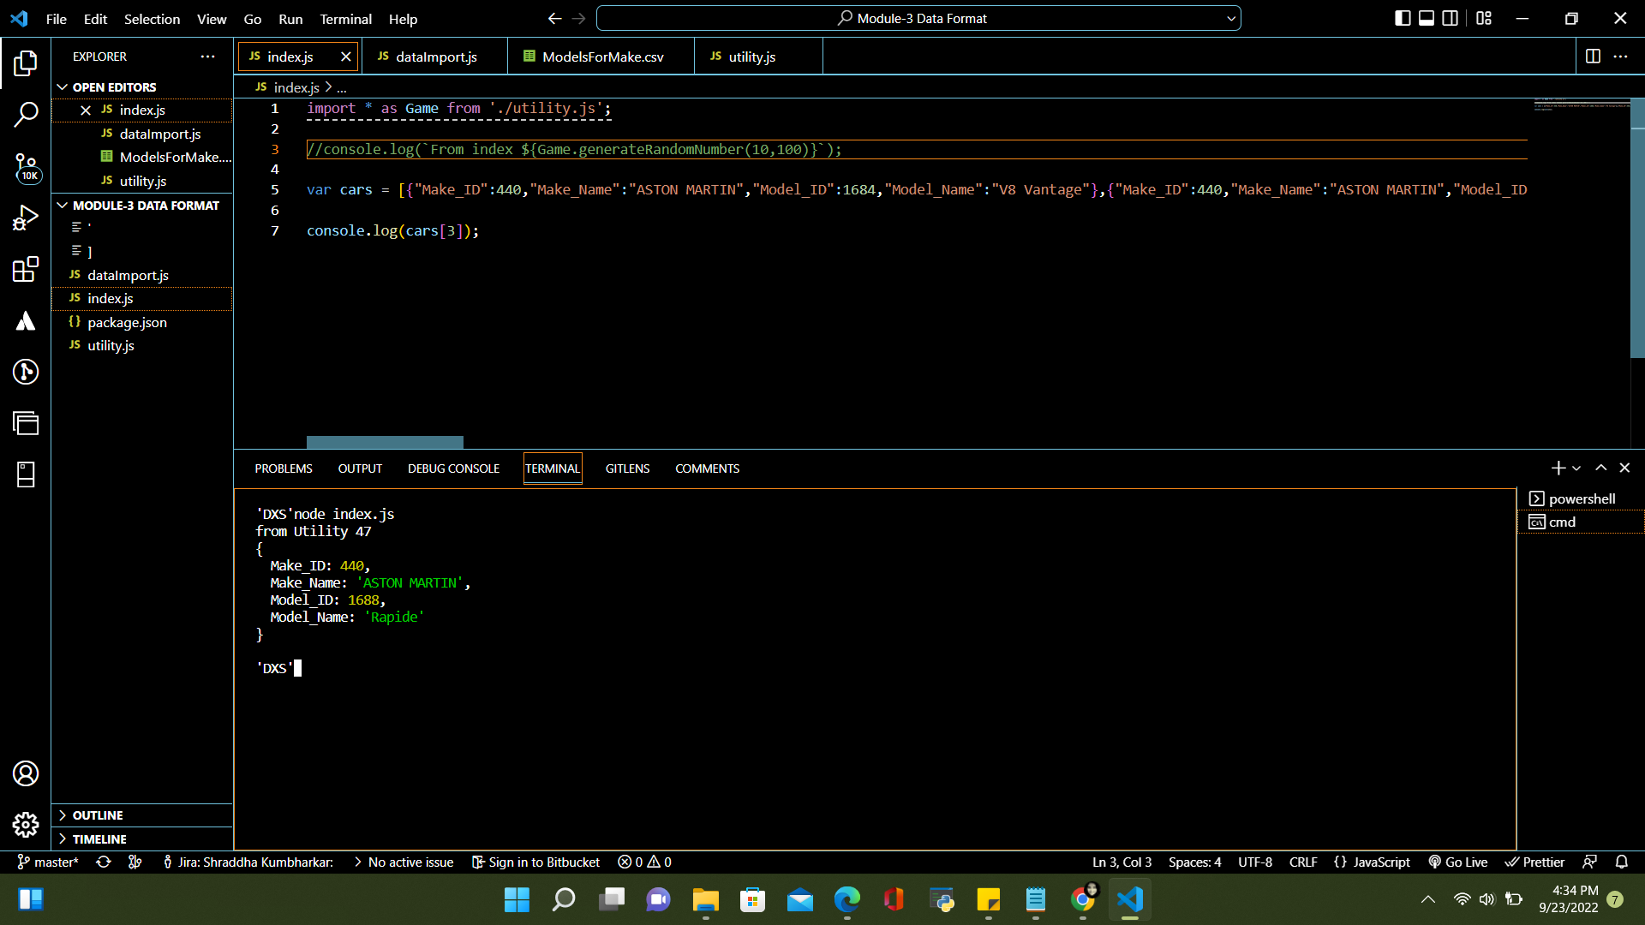

**Data Formats and Data Exchange**

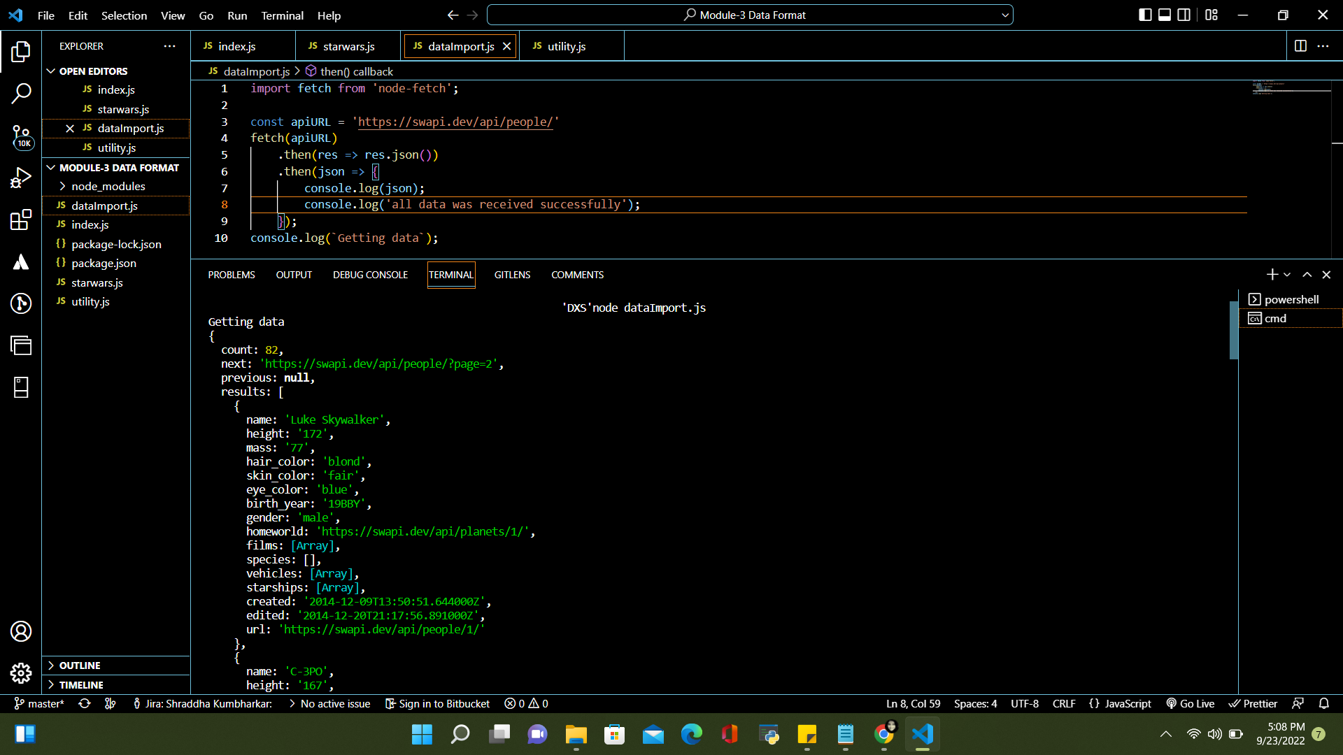

**Printed data with a comment below**

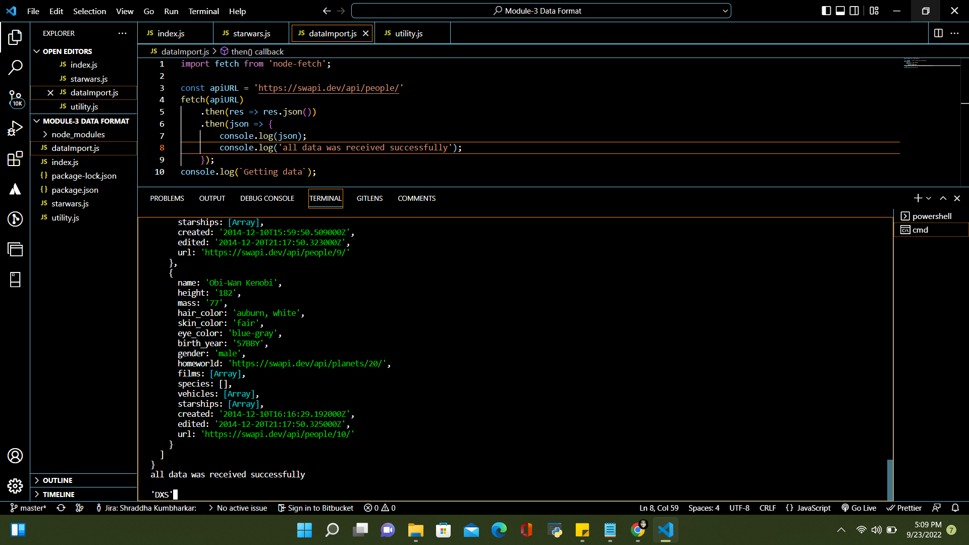

**Content Negotiation**

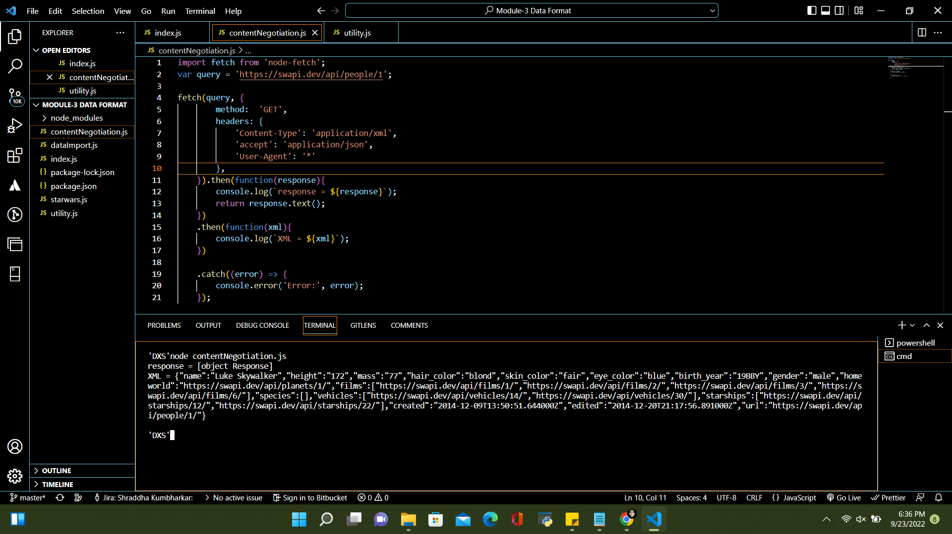

**References**

<https://asu.instructure.com/courses/132658/assignments/3526661?module_item_id=9146113>

<https://github.com/Shradsk/Middleware/upload/Assignment3-Data_Format>